**FREELANCING WEBSITE USING MERN**

**Introduction**

* **Project Title:** TalentHive
* **Team ID (NM2024TMID11577)**
* **Team Members:** 
  + - Sathish A
    - Sabarishwar S R
    - Nithish M
    - Yuvaraj K
    - Saam B

**Project Overview**

* **Purpose:** TalentHive is an innovative freelancing platform that bridges the gap between clients in need of specific project-based work and freelancers seeking opportunities to showcase and monetize their skills. The platform is designed to make the project workflow seamless from posting and applying for projects to completing them and processing payments. TalentHive aims to create a transparent and efficient ecosystem that benefits both clients and freelancers, facilitating smooth communication and project management.
* **Goals:** 
  + To offer clients an intuitive and efficient way to post projects with detailed requirements and budget constraints.
  + To provide freelancers with a straightforward method to browse, apply for, and manage projects.
  + To ensure project completion and payment processes are secure and user-friendly.
  + To empower admins with tools to monitor the platform's activity and manage user interactions effectively.
* **User Roles:**
  + **Client Dashboard:** Clients can post new projects, view ongoing and completed projects, approve or reject project submissions, and communicate with freelancers via the integrated chat feature.
  + **Freelancer Dashboard:** Freelancers can browse available projects, submit proposals with detailed bids, interact with clients through messages, and submit completed project work for approval.
  + **Admin Panel:** The admin role provides oversight capabilities, allowing monitoring of user registrations, project postings, submitted proposals, and chat interactions. Admins can manage and oversee the platform to ensure smooth operations.
* **Project Lifecycle:**
  + Clients post projects specifying requirements and budget.
  + Freelancers browse projects and submit proposals for consideration.
  + Clients review proposals, approve a suitable freelancer, and initiate the project.
  + Freelancers submit completed work, including a project link and description, for client review.
  + Upon client approval of the submitted work, funds are transferred to the freelancer.
* **Chat Functionality:**
  + Real-time chat feature to enhance communication between clients and freelancers, facilitating discussions, clarifications, and project updates.

**Architecture**

* **Frontend**
* **Framework**: React.js
  + **Components**: The frontend is designed using reusable React components that represent different parts of the application, such as user dashboards, project forms, chat interfaces, and notification panels.
  + **Routing**: React Router is utilized for client-side routing, allowing smooth navigation between pages such as the client dashboard, freelancer project listings, and admin panel.
  + **State Management**: The application leverages React's useState and useContext hooks for local and global state management, while more complex data handling is managed using third-party libraries like Redux (if applicable).
  + **Styling**: The UI is styled using CSS-in-JS libraries (e.g., styled-components) or traditional CSS for custom and responsive design, providing a seamless experience across devices.
  + **Security**: Prevents unauthorized access to specific pages with protected routes, verified through token-based authentication.

### **Backend**

* **Framework**: Node.js with Express.js
  + **Structure**: The backend is organized into controllers, routes, and middleware:
    - **Controllers**: Contain the business logic for handling HTTP requests, such as creating projects, handling proposals, and managing user interactions.
    - **Routes**: Define the endpoints and link them to the appropriate controller functions.
    - **Middleware**: Custom middleware ensures secure user sessions, validates JSON Web Tokens (JWT), and processes errors.
  + **Services**: Service modules separate complex operations, such as payment processing or notification handling, from the main controller logic.
  + **Real-Time Communication**: Integrated using libraries like Socket.io for the chat feature, enabling real-time messaging between clients and freelancers.

### **Database**

* **Database System**: MongoDB
  + **Schema Design**:
    - **Users Collection**: Stores user profiles with information like role (client, freelancer, admin), name, email, hashed passwords, and profile details.
    - **Projects Collection**: Contains project details, including the client ID, project description, budget, status (e.g., open, in progress, completed), and associated freelancer proposals.
    - **Proposals Collection**: Captures the proposals submitted by freelancers, including freelancer ID, project ID, bid details, and proposal status.
    - **Chats Collection**: Manages chat data, including sender and receiver IDs, timestamps, and messages.
  + **Relationships**:
    - One-to-many relationship between users and projects (a client can have multiple projects).
    - One-to-many relationship between projects and proposals (a project can have multiple freelancer proposals).
  + **Indexes**: Critical fields, such as user email and project IDs, are indexed to improve query performance.

**Setup Instructions**

* **Prerequisites**

Before setting up the project, ensure you have the following installed:

* **Node.js**: Version 14.x or higher for running JavaScript code outside the browser.
* **MongoDB**: Either a Community Server or a cloud-based MongoDB Atlas account.
* **Git**: For cloning the repository.

### **Installation Steps**

1. Clone the GitHub Repository:
   * Open a terminal or command prompt and navigate to your desired directory.
   * Run the following command to clone the repository: git clone [repository URL]
   * Replace [repository URL] with the actual link to your GitHub repository.
2. Navigate to the Project Directory:

* Change to the root directory of the cloned project: cd TalentHive

1. Install Dependencies:

* The project contains separate folders for the client (frontend) and server (backend).
* Open two terminal windows or command prompts and follow these steps:

**For the Client**:

* Navigate to the client folder: cd client
* Install all Dependencies: npm install

**For the Client**:

* Navigate to the client folder: cd server
* Install all Dependencies: npm install

1. Modify Database Connection:

* Open the index.js file in the server directory.
* Update the MONGO_URI to point to your MongoDB Connection string (local or Altas).

**Folder Structure**

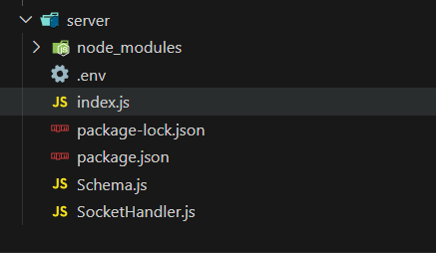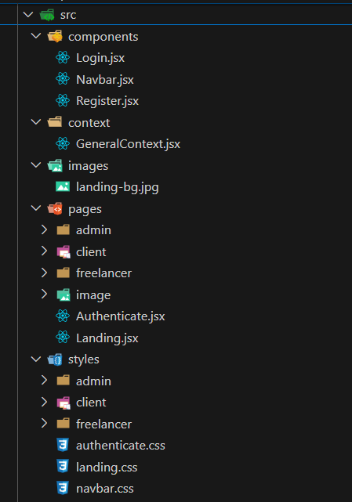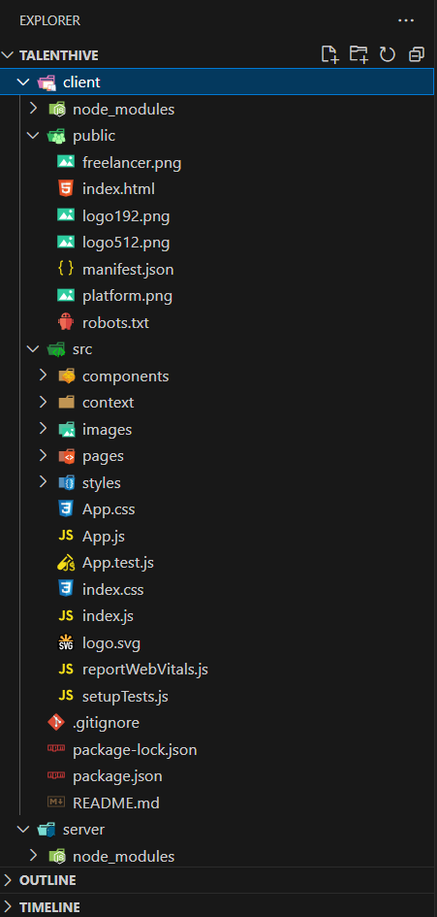

**Running the Application**

* **Frontend:** “npm start” in the client directory.
* **Backend:** “npm start” in the server directory.

**Authentication**





**User Interface**



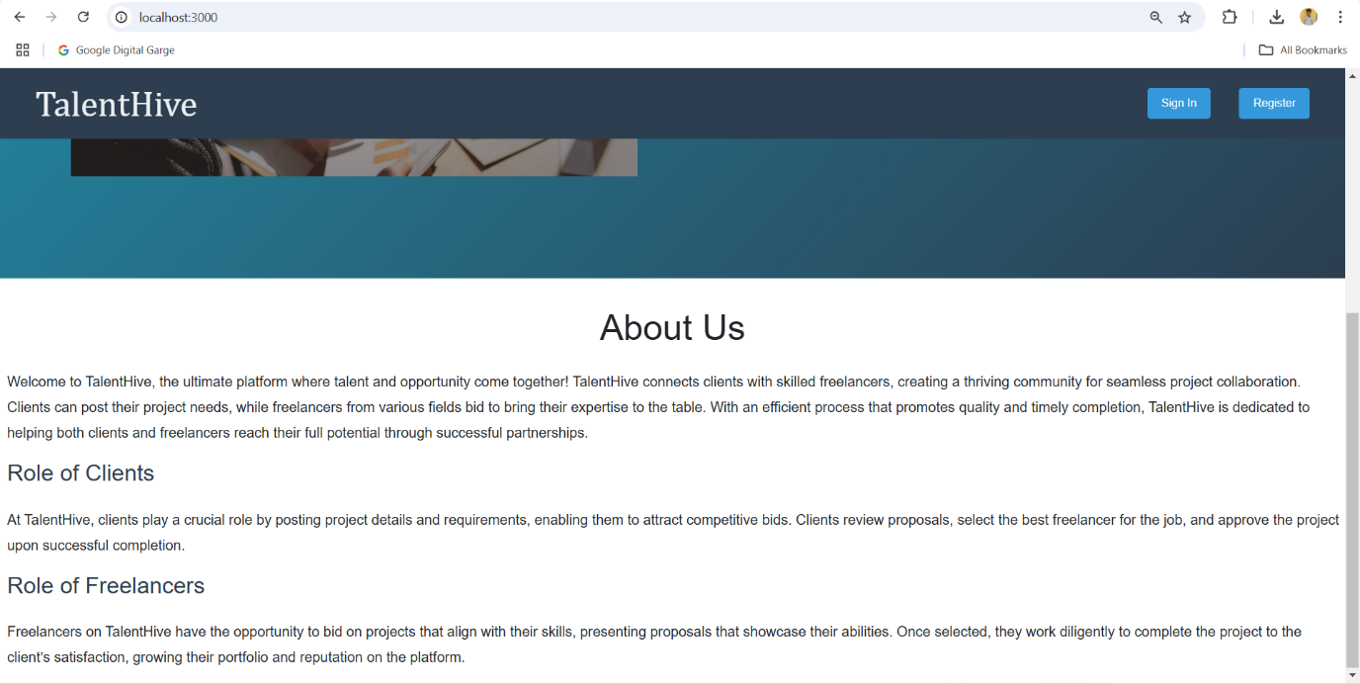

**Screenshots**

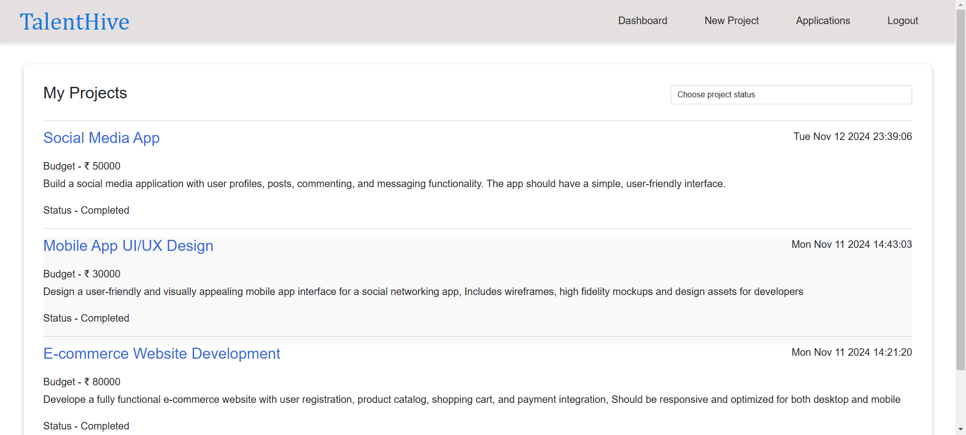**Client’s Dashboard**

**Add Projects**

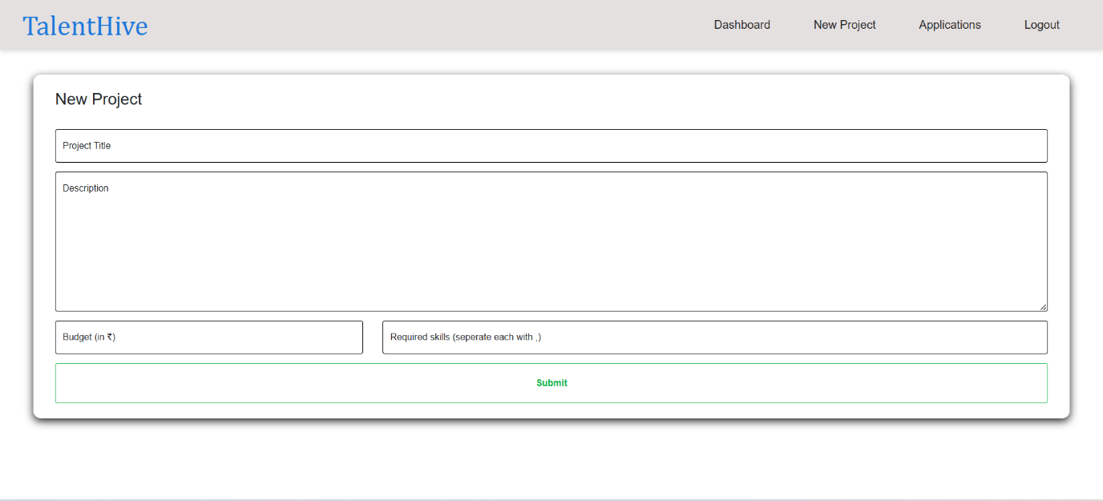

**Freelancer’s Dashboard**

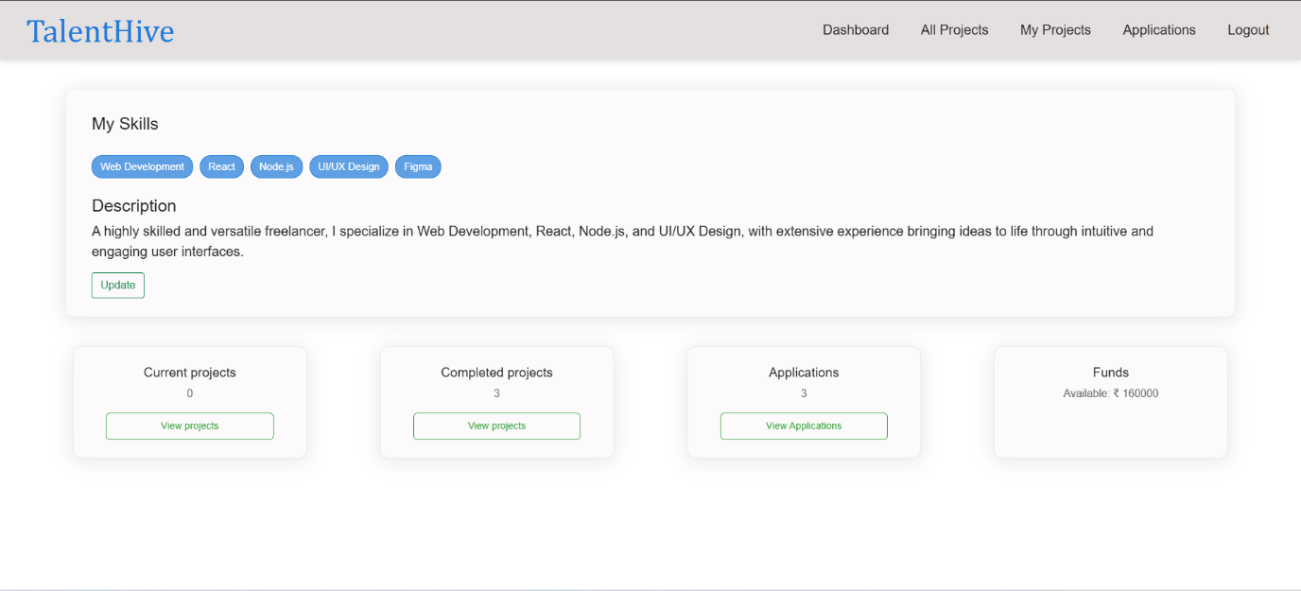

**Freelancer Project Search Page**

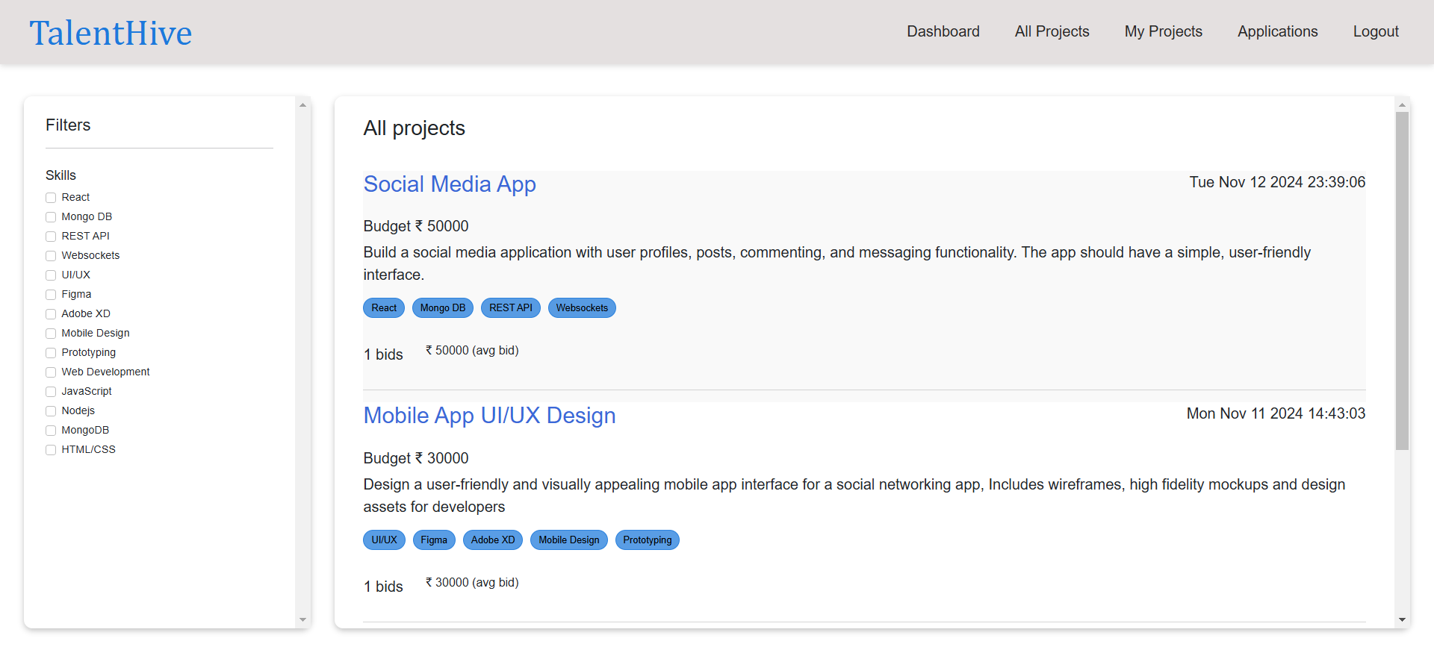

**Admin’s Dashboard**

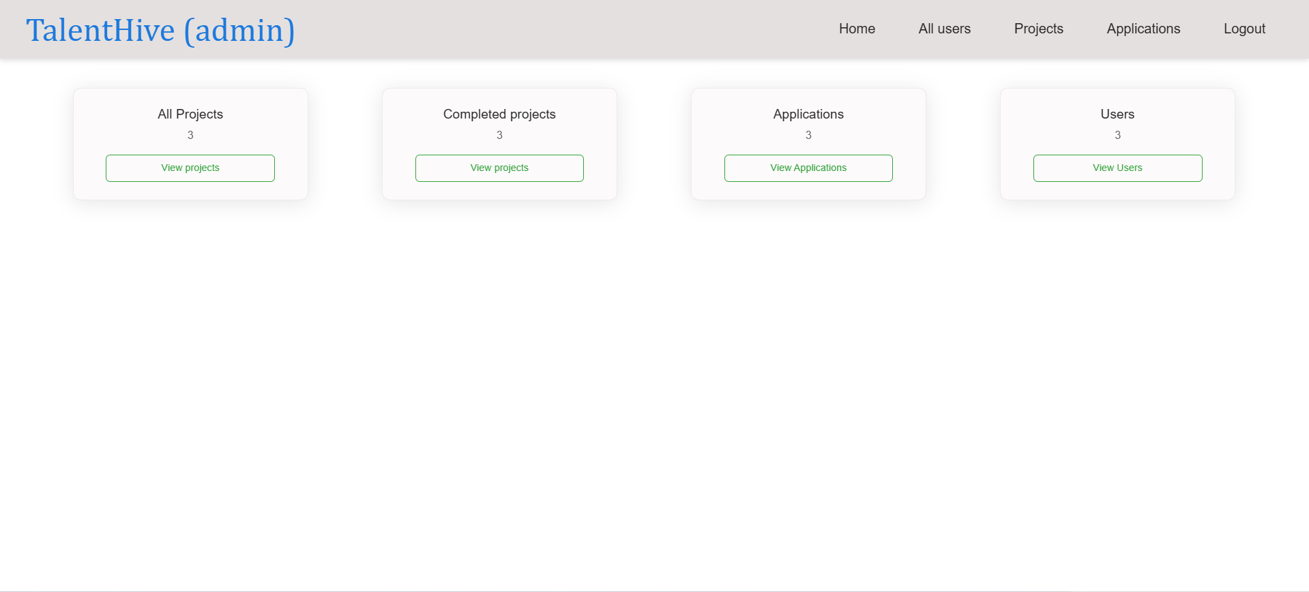

**Future Enhancements**

* **Integrating Payment Gateway**: Implementing a secure payment gateway to enable direct and seamless transactions between clients and freelancers for streamlined project payments.
* **Review System**: Introducing a feature for clients to rate and review freelancers post-project completion, enhancing credibility and trust on the platform.
* **Improved Notification System**: Developing an advanced notification system to keep users updated in real-time about project statuses, proposal responses, and payment confirmations.

**Demonstration Video Link:**

[**https://drive.google.com/file/d/1dmdMfbZt_0GGi6EOPzz8JFDlp7dBJvNO/view?usp=sharing**](https://drive.google.com/file/d/1dmdMfbZt_0GGi6EOPzz8JFDlp7dBJvNO/view?usp=sharing%20)